ASSIGNMENT – 10 (HTML) (KASHISH)
Q.1) Create an HTML page that uses Bootstrap utility classes to add 3 different levels of spacing (margin and padding) around a card displaying a Flipkart-style product image and name.
Ans).
<!DOCTYPE html>
<html lang="en">
<head>
<meta charset="UTF-8">
<meta name="viewport" content="width=device-width, initial-scale=1.0">
<title>Product Card</title>
<link href="https://cdn.jsdelivr.net/npm/bootstrap@5.3.8/dist/css/bootstrap.min.css" rel="stylesheet">
</head>
<body>
<div class="container">
<div class="card m-5 p-4" style="width: 300px;">
<div class="m-2 p-2">
<img src="/Samsung Galaxy S24 Ultra.webp"
class="card-img-top"
alt="Product Image">
</div>
<div class="card-body m-3 p-3">
<h5 class="card-title">Samsung Galaxy S24 Ultra 5G Smartphone</h5>
<p class="card-text">₹79,999</p>
</div>
</div>
</div>
</body>
</html>

Result:
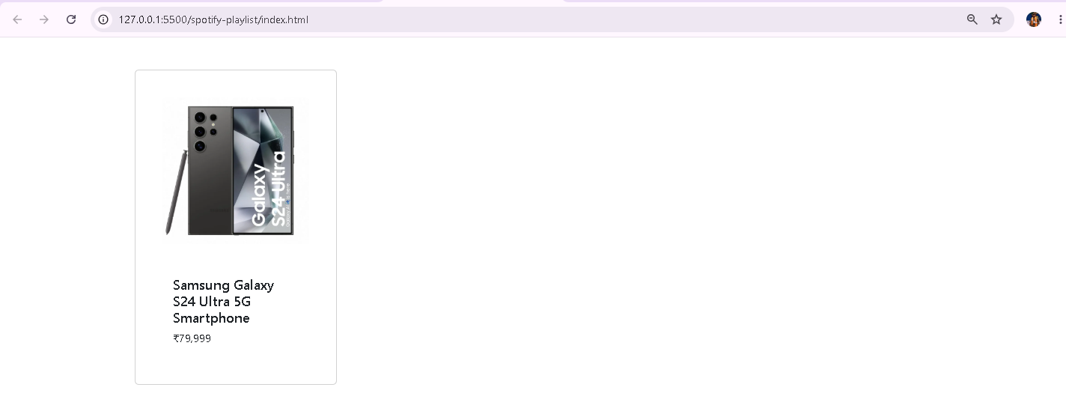

Q.2) Build a movie review card (like BookMyShow) using Bootstrap typography utilities to style the movie title, rating, and review text with different font weights and sizes.
Ans).
<!DOCTYPE html>
<html lang="en">
<head>
<meta charset="UTF-8">
<meta name="viewport" content="width=device-width, initial-scale=1.0">
<title>Movie Review</title>
<link href="https://cdn.jsdelivr.net/npm/bootstrap@5.3.8/dist/css/bootstrap.min.css" rel="stylesheet">
</head>
<body>
<div class="container mt-5">
<div class="card p-4 shadow" style="max-width: 500px;">
<h2 class="fw-bold fs-2">
Avengers: Endgame
</h2>
<p class="fw-semibold fs-4 text-danger">
⭐ 9.2/10
</p>
<p class="fw-normal fs-6">
An amazing movie with great action, emotional moments,
and excellent performances. Definitely worth watching!
</p>
</div>
</div>
</body>
</html>
Result:
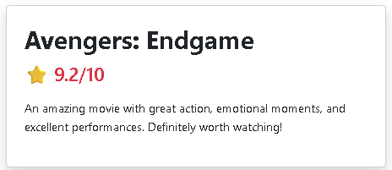

Q.3) Design a Zomato-style restaurant list where each restaurant card uses at least three different Bootstrap color utility classes to highlight ratings, offers, and open/closed status.
Ans).

<!DOCTYPE html>
<html lang="en">
<head>
<meta charset="UTF-8">
<meta name="viewport" content="width=device-width, initial-scale=1.0">
<title>Restaurant List</title>
<link href="https://cdn.jsdelivr.net/npm/bootstrap@5.3.8/dist/css/bootstrap.min.css" rel="stylesheet">
</head>
<body>
<div class="container mt-5">
<h2 class="mb-4">Restaurants Near You</h2>
<div class="card p-3 mb-4 shadow-sm">
<h4>Spice Kitchen</h4>
<span class="badge bg-success">
⭐ 4.5
</span>
<p class="text-danger fw-bold mt-2">
50% OFF up to ₹100
</p>
<p class="text-success fw-semibold">
Open Now
</p>
</div>
<div class="card p-3 mb-4 shadow-sm">
<h4>Pizza House</h4>
<span class="badge bg-warning text-dark">
⭐ 3.9
</span>
<p class="text-primary fw-bold mt-2">
20% OFF
</p>
<p class="text-danger fw-semibold">
Closed
</p>
</div>
</div>
</body>
</html>

Result:
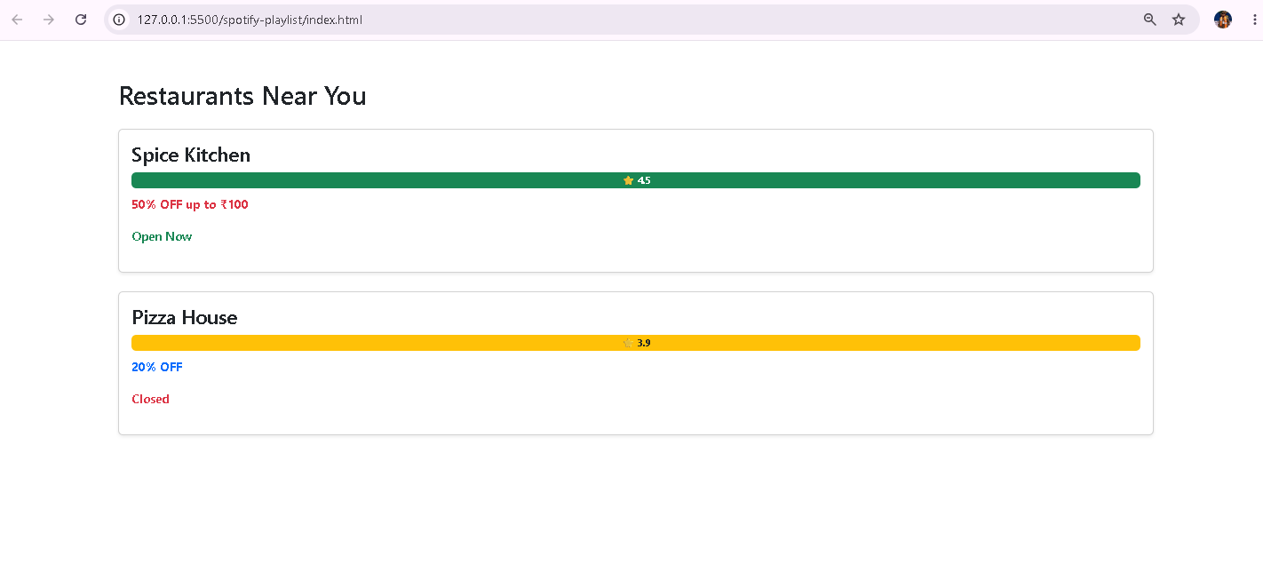

Q.4) Override the Bootstrap primary button color in your own CSS file to use a custom shade (not the default blue), and apply it to a 'Book Ticket' button on your page.<br><br><em><strong>Hint:</strong> Use the CSS selector .btn-primary in your custom stylesheet and link it after the Bootstrap CSS.</em>
Ans).
<!DOCTYPE html>
<html lang="en">
<head>
<meta charset="UTF-8">
<meta name="viewport" content="width=device-width, initial-scale=1.0">
<title>Book Ticket</title>
<!-- Bootstrap CSS -->
<link href="https://cdn.jsdelivr.net/npm/bootstrap@5.3.8/dist/css/bootstrap.min.css" rel="stylesheet">
<!-- Our CSS must come AFTER Bootstrap -->
<link rel="stylesheet" href="style.css">
</head>
<body>
<div class="container mt-5">
<h2>BookMyShow</h2>
<button class="btn btn-primary">
Book Ticket
</button>
</div>
</body>
</html>

Result:
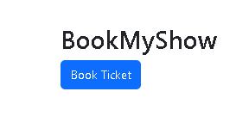

Q.5) Add a theme switcher button to your page that toggles between a light and dark background using Bootstrap classes, and updates the text color for readability.<br><br><em><strong>Hint:</strong> Use JavaScript to toggle 'bg-light'/'bg-dark' and 'text-dark'/'text-light' classes on the main container.</em>
Ans).
<!DOCTYPE html>
<html lang="en">
<head>
<meta charset="UTF-8">
<meta name="viewport" content="width=device-width, initial-scale=1.0">
<title>Theme Switcher</title>
<link href="https://cdn.jsdelivr.net/npm/bootstrap@5.3.8/dist/css/bootstrap.min.css" rel="stylesheet">
</head>
<body>
<div id="mainContainer"
class="container-fluid min-vh-100 bg-light text-dark p-5">
<h1>Movie Booking Website</h1>
<p>
Welcome to our movie booking page. Select your favourite
movie and book your tickets.
</p>
<button class="btn btn-primary" onclick="changeTheme()">
Switch Theme
</button>
</div>
<script>
function changeTheme() {
let container = document.getElementById("mainContainer");
container.classList.toggle("bg-light");
container.classList.toggle("bg-dark");
container.classList.toggle("text-dark");
container.classList.toggle("text-light");
}
</script>
</body>
</html>

Result:
